Mathematics Specialist Investigations

Year 12

Topic 4.2: Rates of change and differential equations

Authors: Rom Cirillo
Margaret Denham
Romaine Saunders
Amy Shaw
Ed Taylor

Editors: Rom Cirillo
Romaine Saunders

For each topic three types of tasks are included:
- Extended investigation – an investigation which could be done in the student’s own time followed by an in-class validation. Solutions are provided where practicable for the preparation activity/investigation. For the in-class validation, there are solutions and marking keys which identify the mathematical behaviours that students may exhibit.
- In-class investigation – an investigation for which no prior preparation is required. Solutions and marking keys are provided.
- Investigative questions – a series of short questions which test the student’s ability to apply their learning, to justify their conclusions, to investigate and to generalise, or to solve problems. Such questions could be included in a response or examination assessment. Solutions and marking key are provided.

Screen shot have been produced using the CASIO ClassPad II emulator or the ti-nspire CAS emulator.

Most graphs and diagrams have been produced using efofex software.

© The investigations and solutions in this publication are for the sole use of staff and students of the purchasing school. It is a breach of copyright to distribute them in whole or part in any form now or in the future to any other school, company or person.

Contents:
MATHEMATICS SPECIALIST: Year 12

3.1 Complex numbers
Task 1: Extended investigation: The Factor and Remainder Theorems
Task 2: In-class investigation: Complex numbers using e^{iθ}
Task 3: Investigative questions

3.2 Functions and sketching graphs
Task 4: Extended investigation: The graphs of rational functions
Task 5: In-class investigation: The absolute value function
Task 6: Investigative questions

3.3 Vectors in three dimensions
Task7: Extended investigation: Systems of equations
Task 8: In-class investigation: Cross product
Task 9: Investigative questions

4.1 Integration and applications of integration
Task10: Extended investigation: The Golden Gate bridge
Task 11: In-class investigation: Which sculpture
Task 12: Investigative questions

4.2 Rates of change and differential equations
Task13: Extended investigation: Slope fields
Task 14: In-class investigation: The logistic function
Task 15: Investigative questions

4.3 Statistical inference
Task16: Extended investigation: TBA
Task 17: In-class investigation: TBA
Task 18: Investigative questions

This package only contains the investigations associated with topic 4.2: Rates of change and differential equations

If your school has purchased the complete set of 18 investigations, you will be informed when the rest are ready for delivery/download.

TASK 13: SLOPE FIELDS

Extended Investigation

Unit 4

Topic 4.2: Rates of change and differential equations

Course-related information

The concepts and skills included in this investigation relate to the following dot points within the WA Mathematics Specialist syllabus.
4.2.3 apply the incremental formula to differential equations
4.2.4 solve simple first order differential equations of the form ; differential equations of the form ; and, in general, differential equations of the form , using separation of variables
4.2.5 examine slope (direction or gradient) fields of a first order differential equation

This task provides opportunities for students to use a visual method to consider the solution of first order differential equations. The ability to choose and use appropriate technology to enhance and extend concept development is also incorporated within some of the items.

Background information
The mathematical skills and understandings that students would need for this task should have been covered in earlier years and also in WA Mathematics Methods syllabus Topic 3.2: Integrals. It is also assumed that students have already covered WA Mathematics Specialist 4.2.3 and 4.2.4 in class and that they have not yet considered WA Mathematics Specialist syllabus 4.2.5 in class.

Task conditions
It is assumed that students will have access to a CAS calculator for the preparation activity but not for the in-class validation. No student notes are required. Students are expected to complete the preparation activity before the in-class validation.

SLOPE FIELDS

Extended investigation Part 1: Preparation activity

An equation involving a derivative is called a differential equation. The order of a differential equation is the order of the highest derivative involved in the equation.

For example, are both first order differential equations whereas are second order differential equations.

In this extended investigation, you will consider first order differential equations of the form .

Example
One solution to the differential equation is .

Check:
and .

The graph of is shown on the axes below.

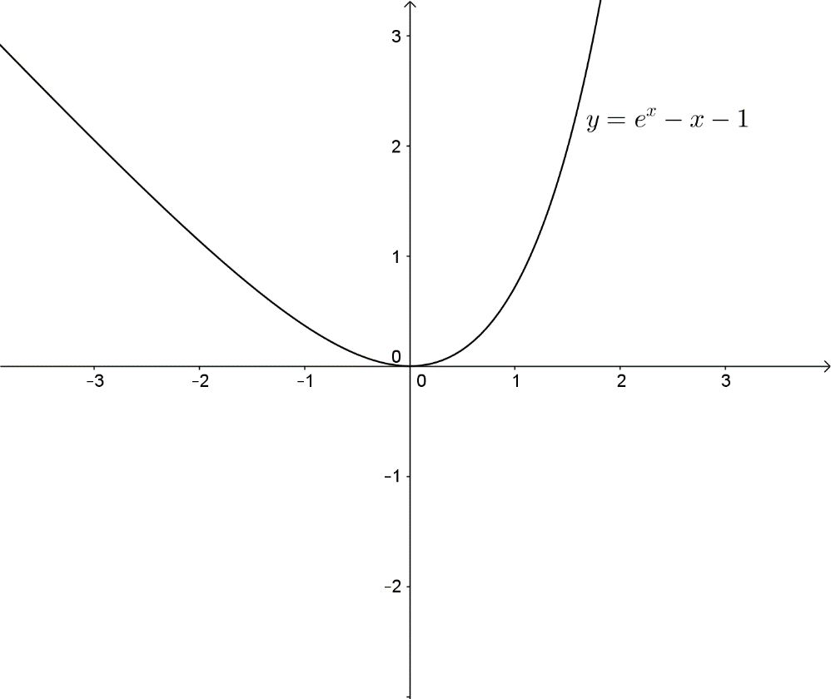
The value of at any given point on the graph of is the slope of the tangent line to the graph at that point.

For example, at so the slope of the tangent line to the graph at the point is approximately .

At so the slope of the tangent line to the graph at the point is .

At so the slope of the tangent line to the graph at the point is approximately .

The diagram below shows the graph of together with the graphs of the three tangent lines at .

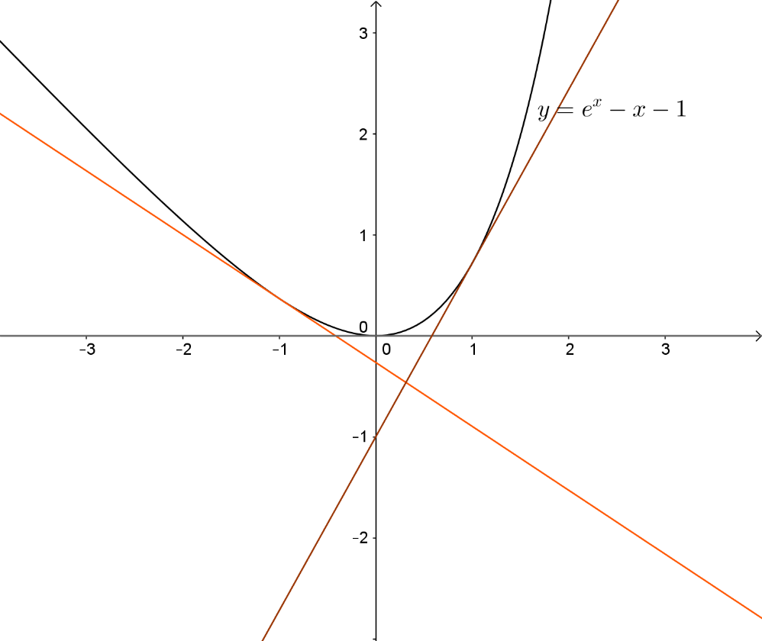

Without knowing the solution of the differential equation whose graph passes through the point , we do know that the slope of the tangent line to this graph at the point is .
For example, at the point , which tells us that is the slope of the line tangential to the graph of the solution of the differential equation whose graph passes through . Drawing a very short line segment, a “minitangent”, with slope 2 at the point gives us visual information about the graph of the solution of the initial value problem .

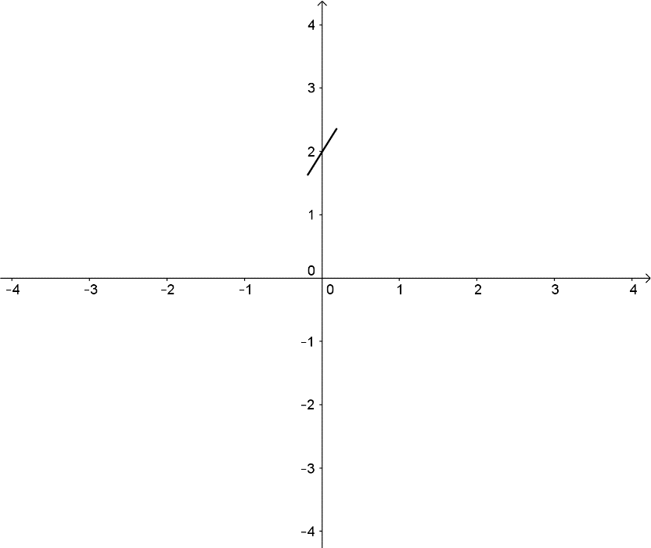
The actual solution of the initial value problem is . The graph of this solution is shown below.

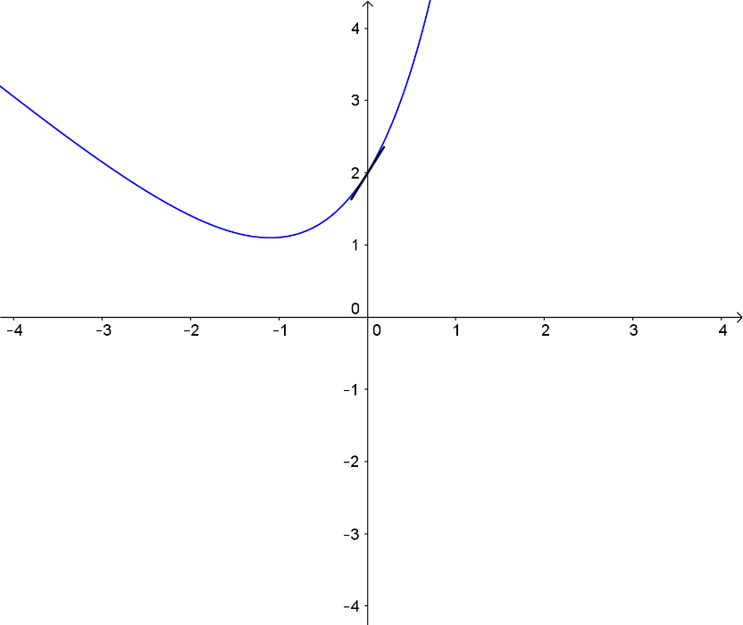
To obtain a visual picture of what the family of solutions of looks like, choose a large number of points, calculate the value of and draw “minitangents” at each of these points. The picture is called a slope field.

 | -2 | -2 | -2 | 0 | 0 | 0 | 2 | 2 | 2
 | -2 | 0 | 2 | -2 | 0 | 2 | -2 | 0 | 2
 | -4 | -2 | 0 | -2 | 0 | 2 | 0 | 2 | 4

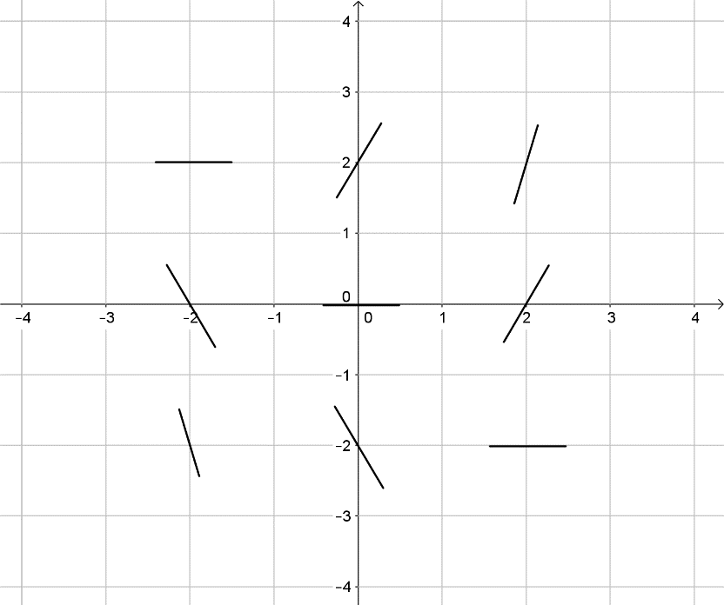

Use a CAS calculator to obtain a better picture as this uses more points.
Tap , enter x+y, tap E, tap O. Use 6 to adjust the viewing window.
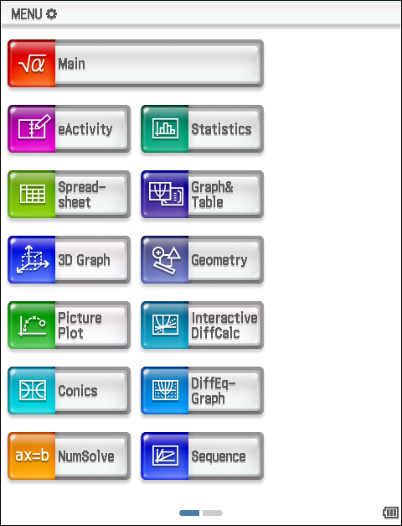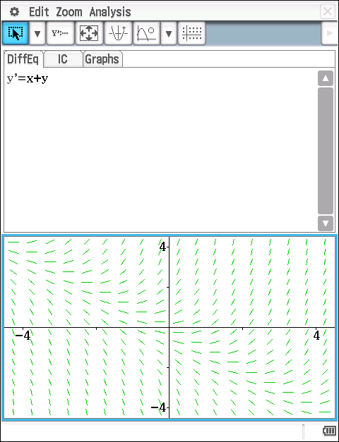

Tap r for a larger viewing window; this window can be readjusted by tapping 6.
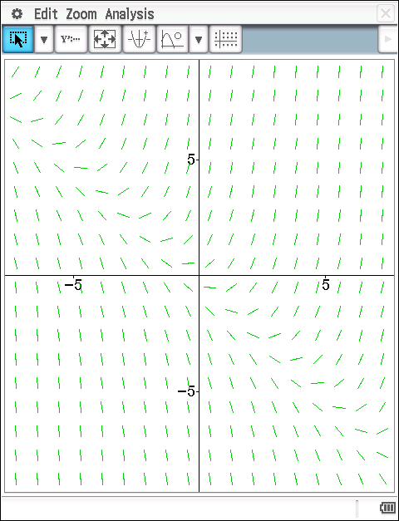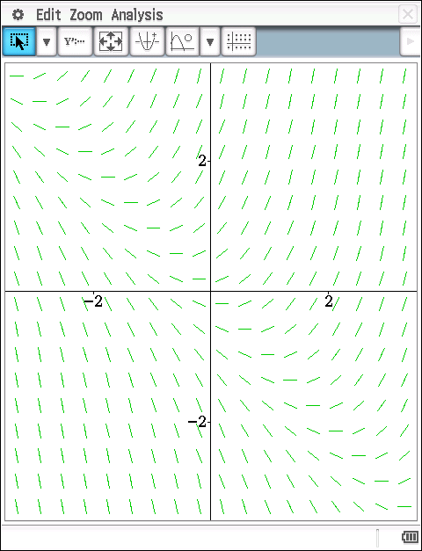

Notice that the line appears to pass through the point (0,-1).
The line is a solution of the differential equation .
Check:

From the slope field, it appears that the solutions whose graphs lie above the line approach the line as and the solutions whose graphs lie below the line approach the line as .

In fact, the family of solutions of are of the form When

Solutions whose graphs lie above the line correspond to positive values of and solutions whose graphs lie below the line correspond to negative values of as shown in the diagram below.

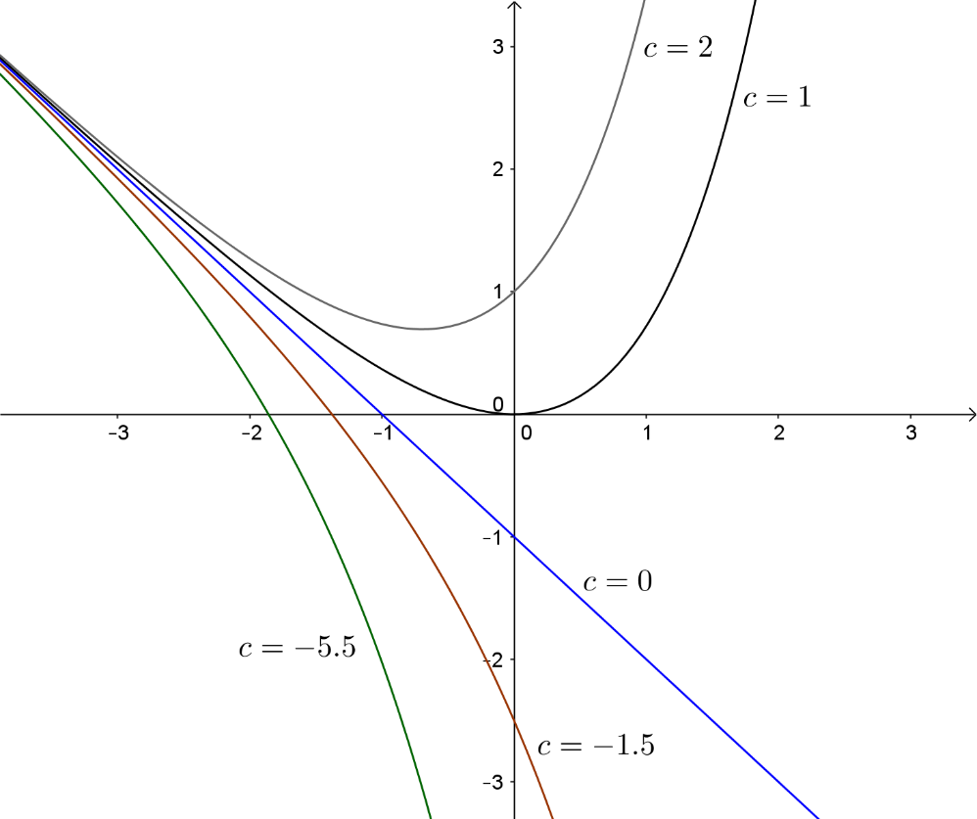

Using the CAS calculator, the graph of a particular solution to the differential equation can be drawn. For example, to draw the graph that passes through the point , tap IC, enter the initial condition x=1, y=3, tap E, tap O. Tap r for a larger viewing window.
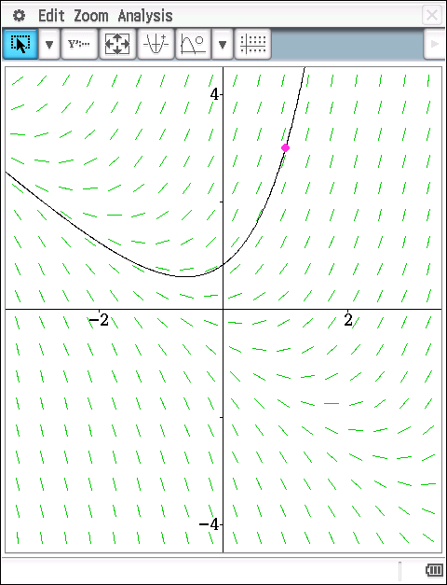

Summary
Slope fields enable us to visualise a family of antiderivatives, solutions of differential equations.

Slope fields are drawn by drawing short line segments for a given point and slope.

When drawing slope fields, identify
- points that have the same slope
- points that have the opposite slope
- points where the slope is zero
- points where the slope is undefined
- where the slope becomes steeper
- where the slope becomes flatter

Question 1
(a) Find all functions that satisfy .

(b) Find the particular solution to the equation whose graph passes through the point .

Question 2
On each of the axes provided below, draw a slope field for the differential equation at the nine points indicated.

(a)

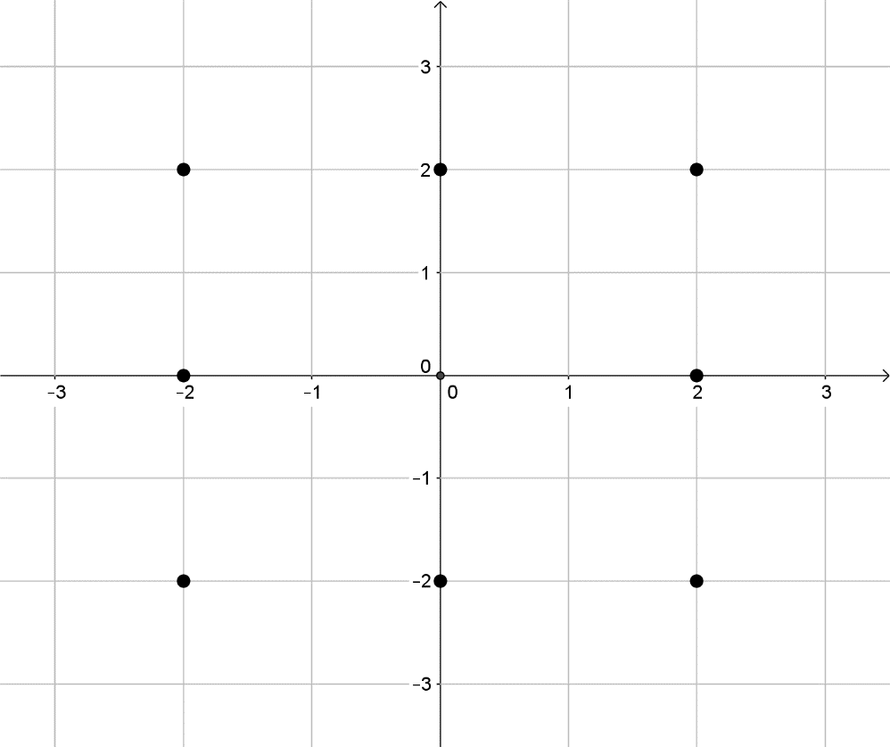

(b)



(c)



Question 3
(a) On the slope field below, draw a graph representing the particular solution for .

Starting at the point , the graph should be parallel to the slope lines, and be an ‘average’ of the slopes if it goes between the lines. Draw both to the right and to the left of .

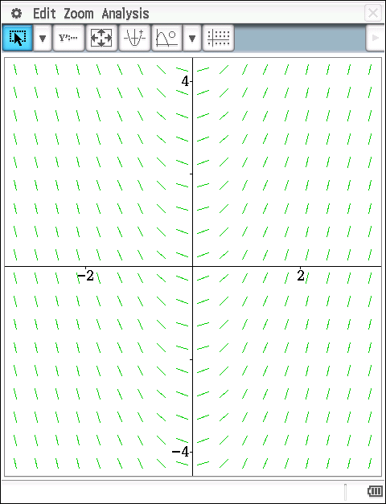

(b) What do you notice about the shape of the solution curves?

(c) What do you notice about the slope for points on the same vertical line? Explain.
(6 marks)

Use your CAS calculator to investigate slope fields for other first order differential equations.
SLOPE FIELDS

Extended investigation Part 1: Preparation activity
Solutions

Question 1(a)
Solution

Question 1(b)
Solution

Question 2(a)
Solution
 | -2 | -2 | -2 | 0 | 0 | 0 | 2 | 2 | 2
 | 2 | 0 | -2 | 2 | 0 | -2 | 2 | 0 | -2
 | 4 | 4 | 4 | 4 | 4 | 4 | 4 | 4 | 4

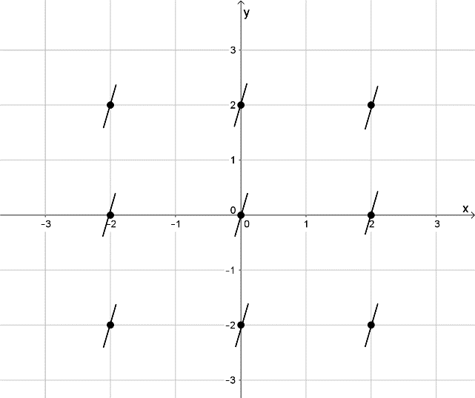

Question 2(b)
Solution
 | -2 | -2 | -2 | 0 | 0 | 0 | 2 | 2 | 2
 | 2 | 0 | -2 | 2 | 0 | -2 | 2 | 0 | -2
 | 2 | 2 | 2 | 0 | 0 | 0 | 2 | 2 | 2

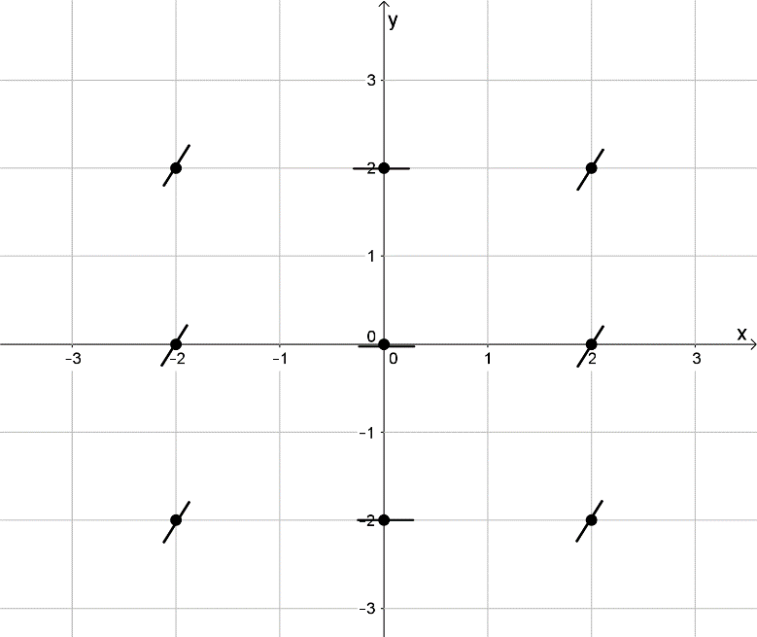

Question 2(c)
Solution
 | -2 | -2 | -2 | 0 | 0 | 0 | 2 | 2 | 2
 | 2 | 0 | -2 | 2 | 0 | -2 | 2 | 0 | -2
 | -6 | -2 | 2 | -4 | 0 | 4 | -2 | 2 | 6

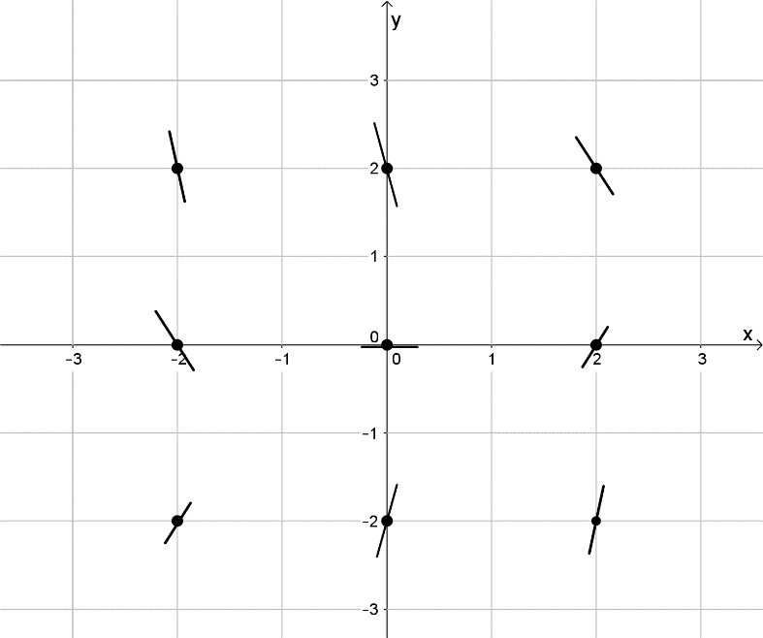

Question 3(a)
Solution
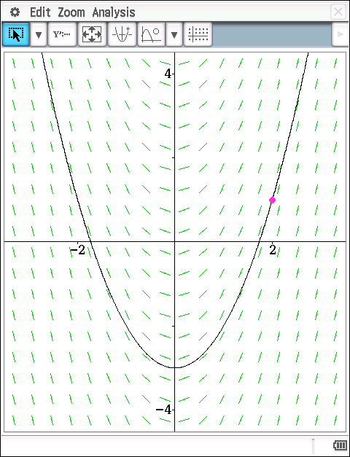

Question 3(b)
Solution
The curves appear to have a parabolic shape.
Question 3(c)
Solution
Since does not depend on , the slope of the solution curves along any vertical line will be the same because these points all have the same .

SLOPE FIELDS

Extended investigation Part 2: In-class validation (40 marks)

Question 1 (5 marks)
(a) On the axes provided, sketch a slope field for the given differential equation at the points indicated. (3)

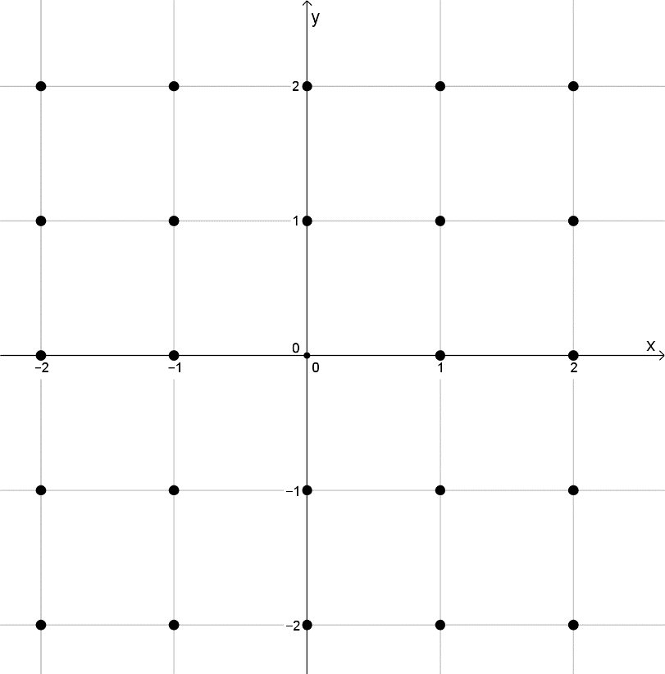

(b) What do you notice about the slope for points on the same horizontal line? Explain. (2)

Question 2 (5 marks)
(a) Match the slope fields with their differential equations. (3)

(A) (B)
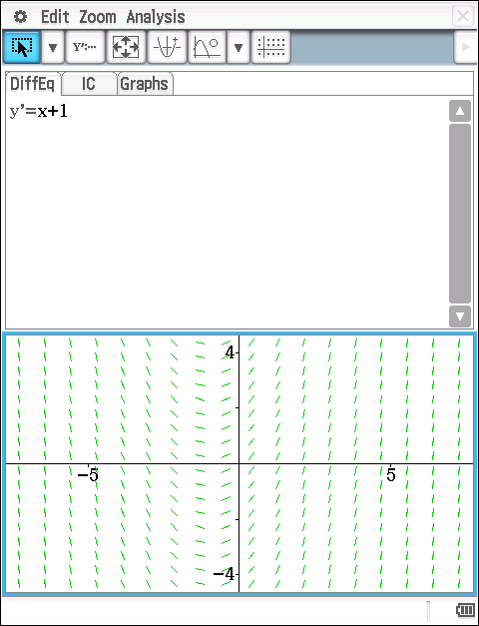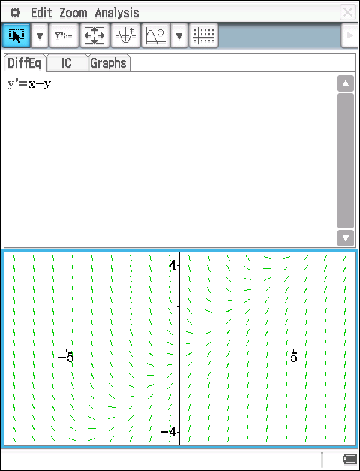

(C) (D)
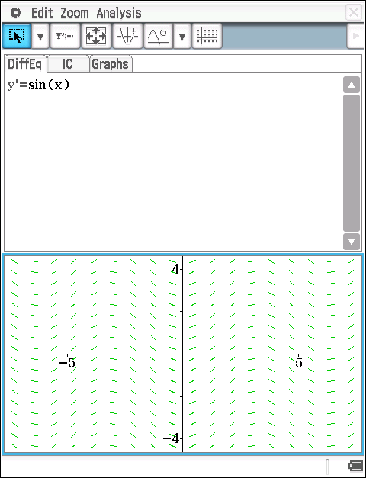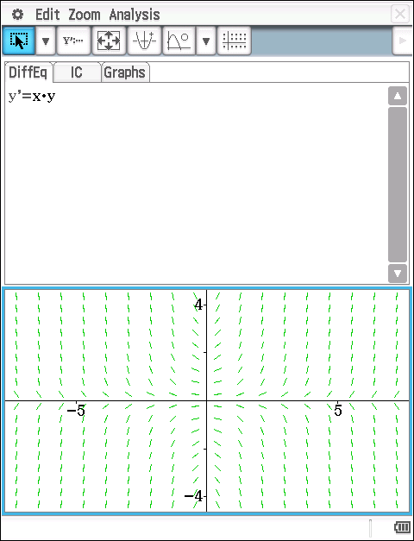

(i) (ii) (iii) (iv)

(b) When will the slope field for the differential equation have horizontal segments? (1)

(c) The slope field from a certain differential equation is shown below.
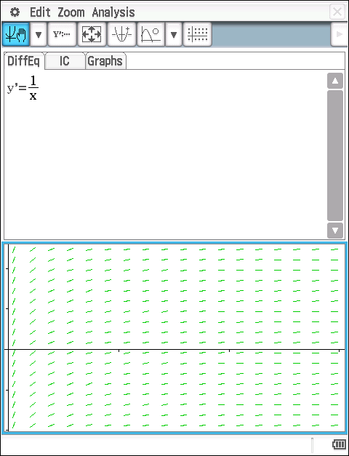
Which of the following could be a specific solution to that differential equation?
(A) (B) (C) (D) (E)
(1)
Question 3 (11 marks)
Consider the differential equation .
(a) On the axes provided, sketch a slope field for the given differential equation at the six points indicated. (2)

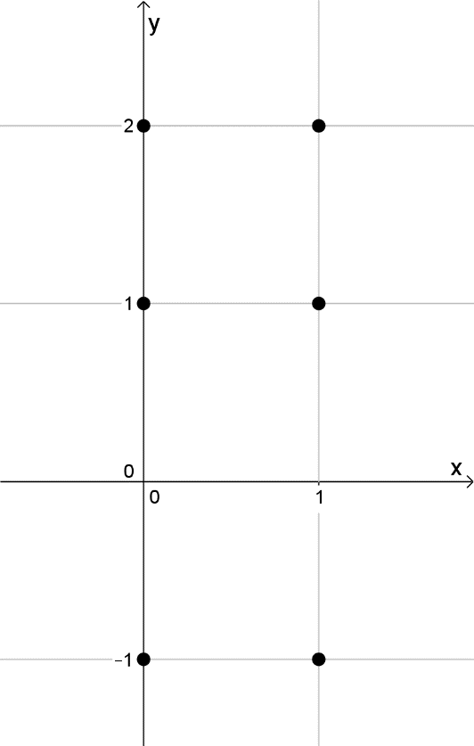

(b) Express in terms of and hence determine the concavity of all solution curves for the differential equation in the second quadrant. Give a reason for your answer. (3)

(c) Let be the particular solution to the differential equation with the initial condition . Does have a relative minimum, a relative maximum, or neither at ? Justify your answer. (2)

(d) Find the values of the constants for which is a solution to the differential equation. (4)

Question 4 (9 marks)
Consider the differential equation . Let be the particular solution to the differential equation with the initial condition . The function is defined for all real numbers.

(a) Sketch the solution curve through the point on the slope field below. (1)

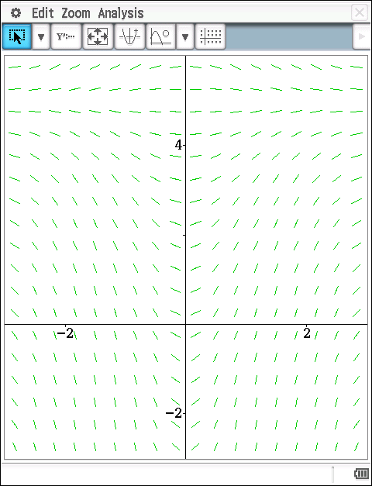

(b) Determine the equation of the line tangential to the solution curve at the point and then use this equation to approximate . (4)

(c) Determine , the particular solution to the differential equation with the initial condition . (4)

Question 5 (10 marks)
Consider the differential equation .
(a) Determine and draw horizontal tangents for each of these values on the axes below. (4)

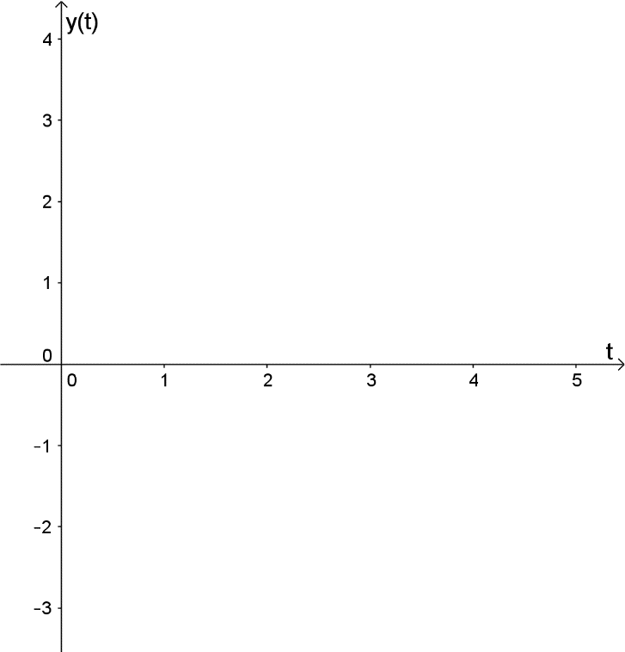

(b) Complete the table below. (6)
Value of | Behaviour of as
SLOPE FIELDS

Extended investigation Part 2: In-class validation
Solutions and marking key

Question 1(a)
Solution
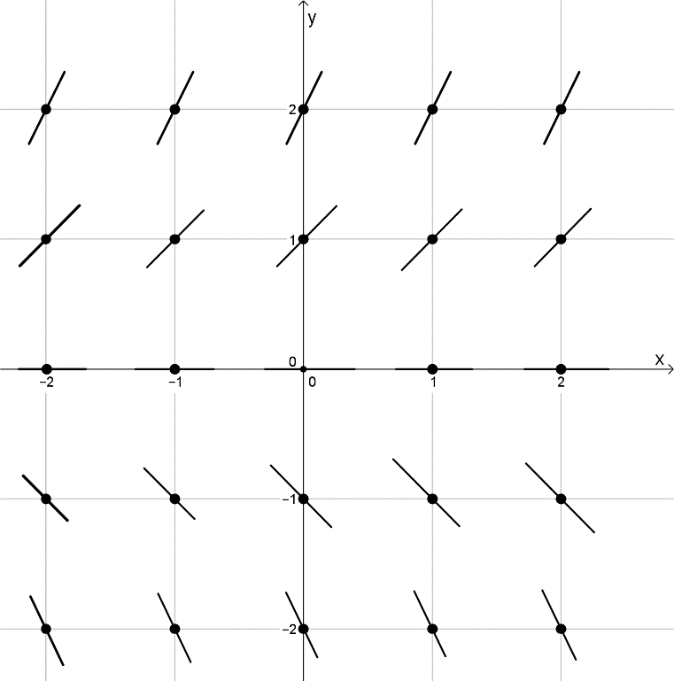
Mathematical behaviours | Marks
- Correct positive slopes  - Correct horizontal slopes  - Correct negative slopes | 1  1  1

Question (b)
Solution
Since does not depend on , the slope of the solution curves along any horizontal line will be the same because these points all have the same .
Mathematical behaviours | Marks
- Correct observation  - Justifies observation | 1  1

Question 2(a)
Solution
(i) graph D
(ii) graph B
(iii) graph A
(iv) graph C
Mathematical behaviours | Marks
- Correctly matches all four graphs  - Correctly matches exactly two graphs  - Correctly matches exactly one graph | 3  2  1

Question 2(b)
Solution
will have horizontal segments when .
Mathematical behaviours | Marks
- Correct condition for horizontal segments | 1

Question 2(c)
Solution
(E)
Mathematical behaviours | Marks
- Chooses correct solution | 1

Question 3(a)
Solution
 | 0 | 0 | 0 | 1 | 1 | 1
 | 2 | 1 | -1 | 2 | 1 | -1
 | -4 | -2 | 2 | -1 | 1 | 5

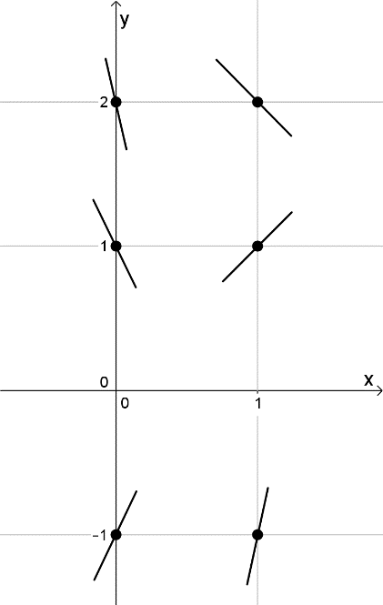

Mathematical behaviours | Marks
- Correct slopes for  - Correct slopes for | 1  1

Question 3(b)
Solution
In the second quadrant .
Therefore, all solution curves in the second quadrant are concave up.
Mathematical behaviours | Marks
- Expresses in terms of  - Concludes concave up  - Justifies conclusion | 1  1  1

Question 3(c)
Solution
Mathematical behaviours | Marks
- Evaluates at  - Correct conclusion with justification | 1  1

Question 3(d)
Solution
Mathematical behaviours | Marks
- Correct gradient for  - Recognises  - Solves for  - Solves for | 1  1  1  1

Question 4(a)
Solution
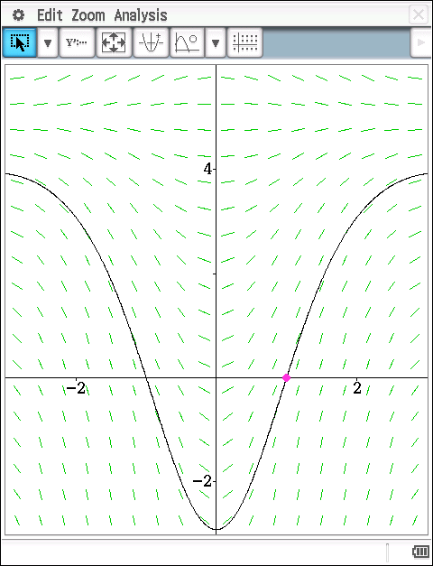
Mathematical behaviours | Marks
- Sketches solution curve through the point | 1

Question 4(b)
Solution
Mathematical behaviours | Marks
- Correct gradient at  - Determines equation of tangent at  - Applies the incremental formula  - Approximates | 1  1  1  1

Question 4(c)
Solution
Mathematical behaviours | Marks
- Separates variables  - Determines antiderivatives  - Solves for the constant  - Determines the particular solution | 1  1  1  1

Question 5(a)
Solution

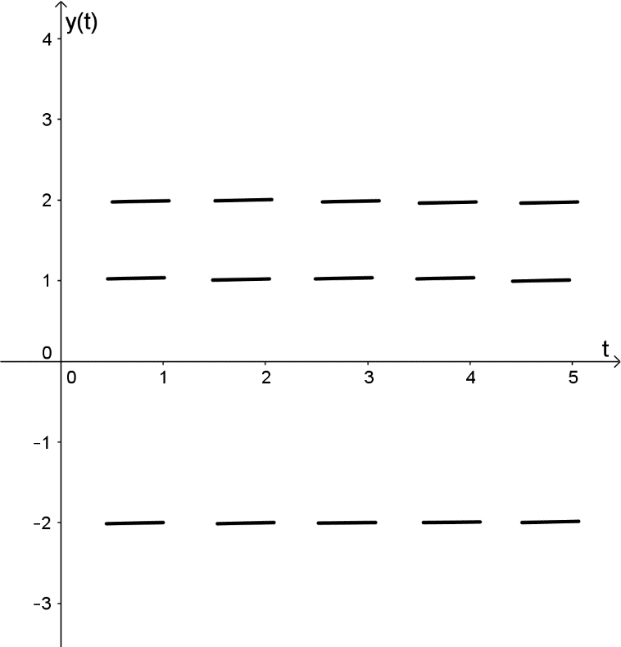
Mathematical behaviours | Marks
- Solves  - Factorises  - Determines the values of  - Draws horizontal tangents for | 1  1  1  1

Question 5(b)
Solution
Value of | Behaviour of as

Mathematical behaviours | Marks
- Uses to determine behaviour of as  - Correct behaviour for  - Correct behaviour for  - Correct behaviour for  - Correct behaviour for  - Correct behaviour for | 1  1  1  1  1  1

TASK 14: THE LOGISTIC FUNCTION

In-class investigation

Unit 4

Topic 4.2: Rates of change and differential equations

Course-related information

The concepts and skills included in this investigation relate to the following dot points within the WA Mathematics Specialist syllabus.
4.2.4 solve simple first order differential equations of the form ; differential equations of the form ; and, in general, differential equations of the form , using separation of variables.
4.2.6 formulate differential equations, including the logistic equation that will arise in, for example, chemistry, biology and economics, in situations where rates are involved

The ability to choose and use appropriate technology to enhance and extend concept development is also incorporated within some of the items.

Background information
The mathematical skills and understandings that students would need for this task should have been covered in earlier years and also in WA Mathematics Methods 3.1.7, 4.1.1 – 4.1.3, 4.1.9 – 4.1.14 and in WA Mathematics Specialist 4.1.3 and 4.1.4. It is also assumed that students have already covered WA Mathematics Specialist 4.2.4 in class and that they have not yet considered WA Mathematics Specialist 4.2.6 in class.

Task conditions

For this task it is assumed that students will have access to a CAS calculator. No student notes are required.

The logistic function

In-class investigation (Total marks: 41)

Question 1 (11 marks)

(a) Sketch the following functions on the axes provided showing clearly the horizontal asymptote(s) and vertical intercept.
(i) (2)
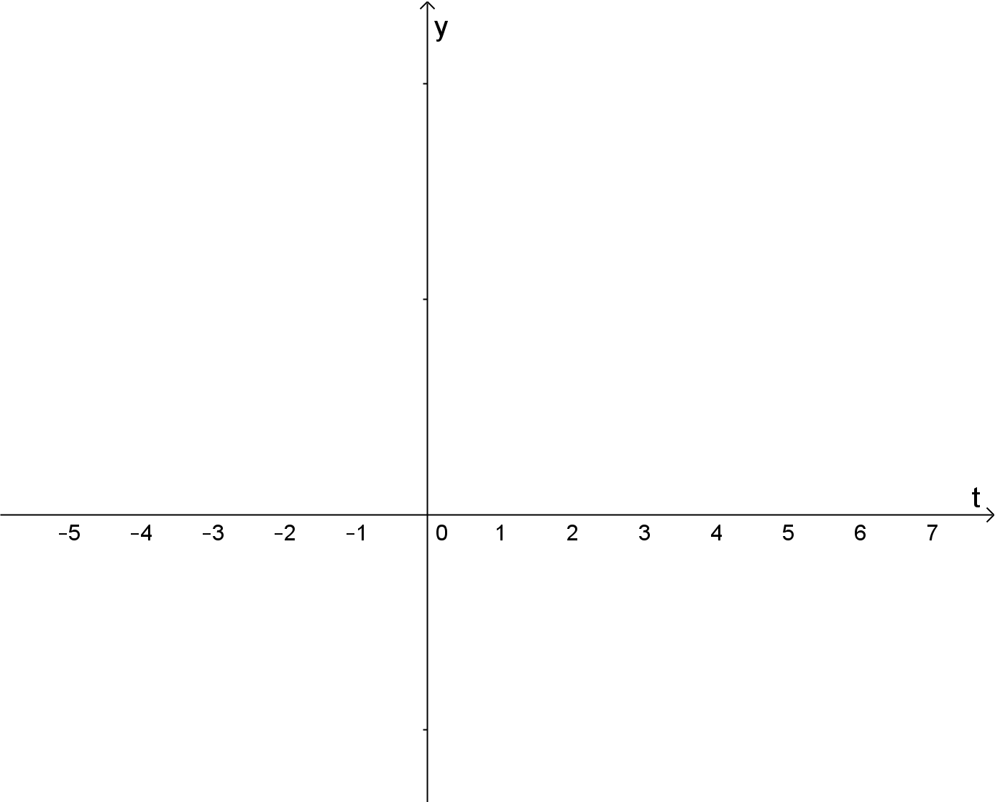
(ii) (2)
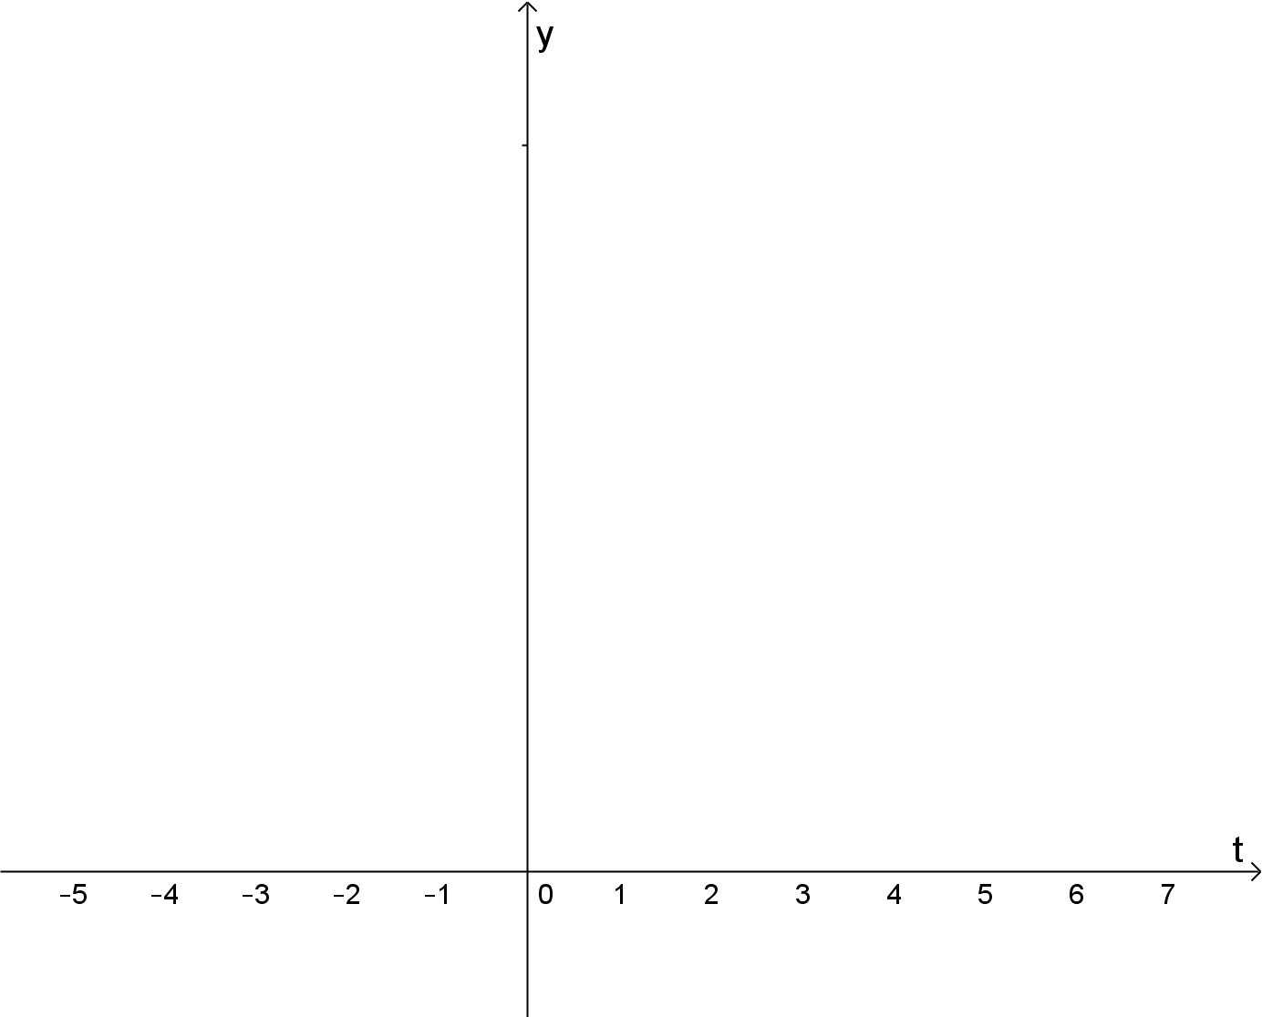

(iii) (2)


(b) Consider the graph of where are positive constants. Determine the following in terms of .

(i) the horizontal asymptote(s), (2)

(ii) the vertical intercept, (1)

(iii) the domain, (1)

(iv) the range. (1)

Question 2 (10 marks)

In 1900, the population of a country was 5.3 million; in 1950, the population was 23.1 million.

(a) Assuming that the rate of change of population is proportional to the size of the population, i.e. , predict the population for this country in 2000 and in 2050. (5)

In reality the model used in (a) is unrealistic because eventually limitations on space, food supply, or other resources impose limitations to population growth. A better model is described by the differential equation

This equation is known as the logistic differential equation.

The general solution to this differential equation is where is a constant.
, hence the levelling out or limiting population (also called the carrying capacity) is .

(b) Show that the logistic equation may be written as
(1)

(c) Given that the actual population of this country in 2000 was 76 million, use the logistic equation and the actual population data for 1950 and 2000 to predict the population in 2050.
(3)

(d) What is the carrying capacity for this country. (1)

Question 3 (7 marks)

The carrying capacity of a population of perch in a lake is 3500. On 1 January 2015 there were 2400 perch in the lake and one year later, on 1 January 2016, the population is 2800 perch.

(a) Predict the perch population in this lake on 1 January 2017. (4)

(b) When will the perch population be expected to reach 3400? (3)

Question 4 (13 marks)

(a) Use Calculus to show that if then . (4)

(b) Use partial fractions to show that . (4)

(c) Hence, use separation of variables to show that is a general solution of the logistic differential equation . (5)

The logistic function

In-class investigation
Solutions and marking key

Question 1 (a)(i)
Solution
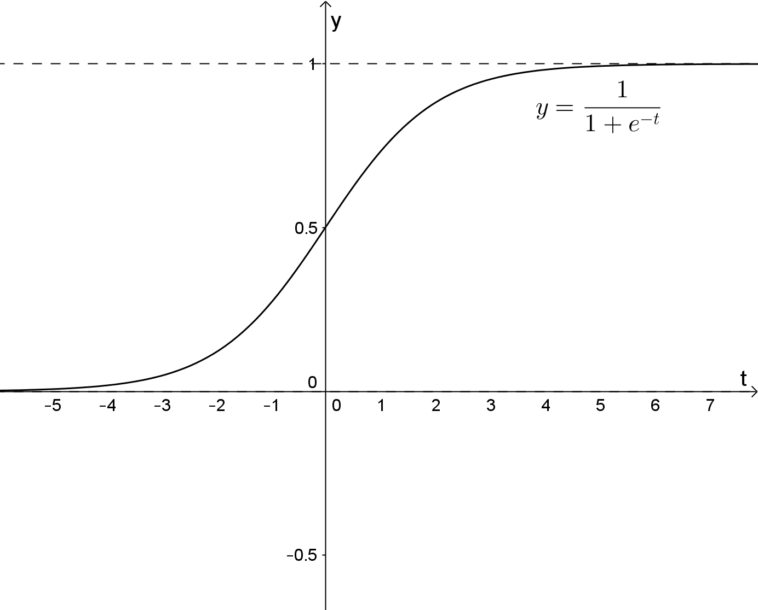
Mathematical behaviours | Marks
- Correct shape  - Shows asymptotes and vertical intercept | 1  1

Question 1 (a)(ii)
Solution
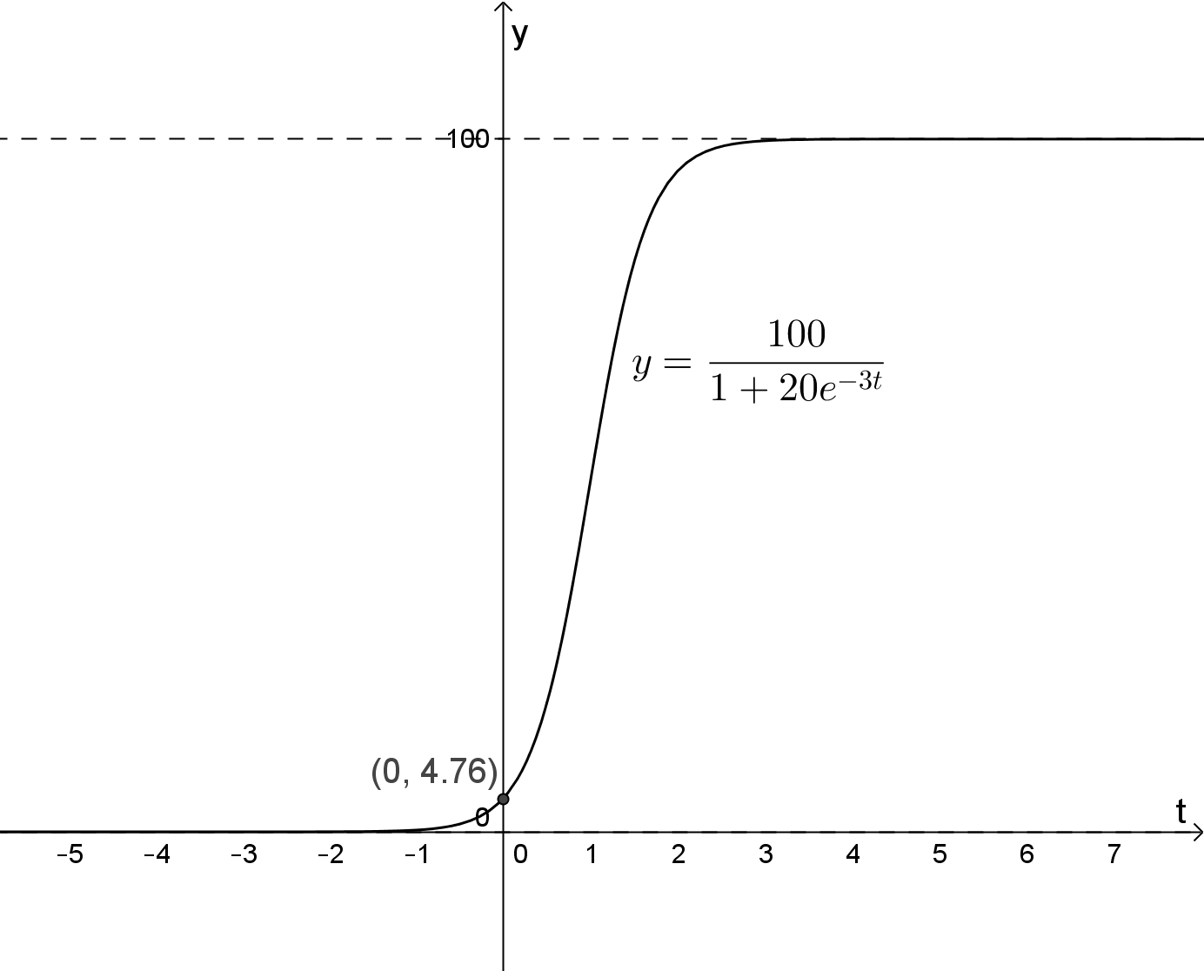
Mathematical behaviours | Marks
- Correct shape  - Shows asymptotes and vertical intercept | 1  1

Question 1 (a)(iii)
Solution
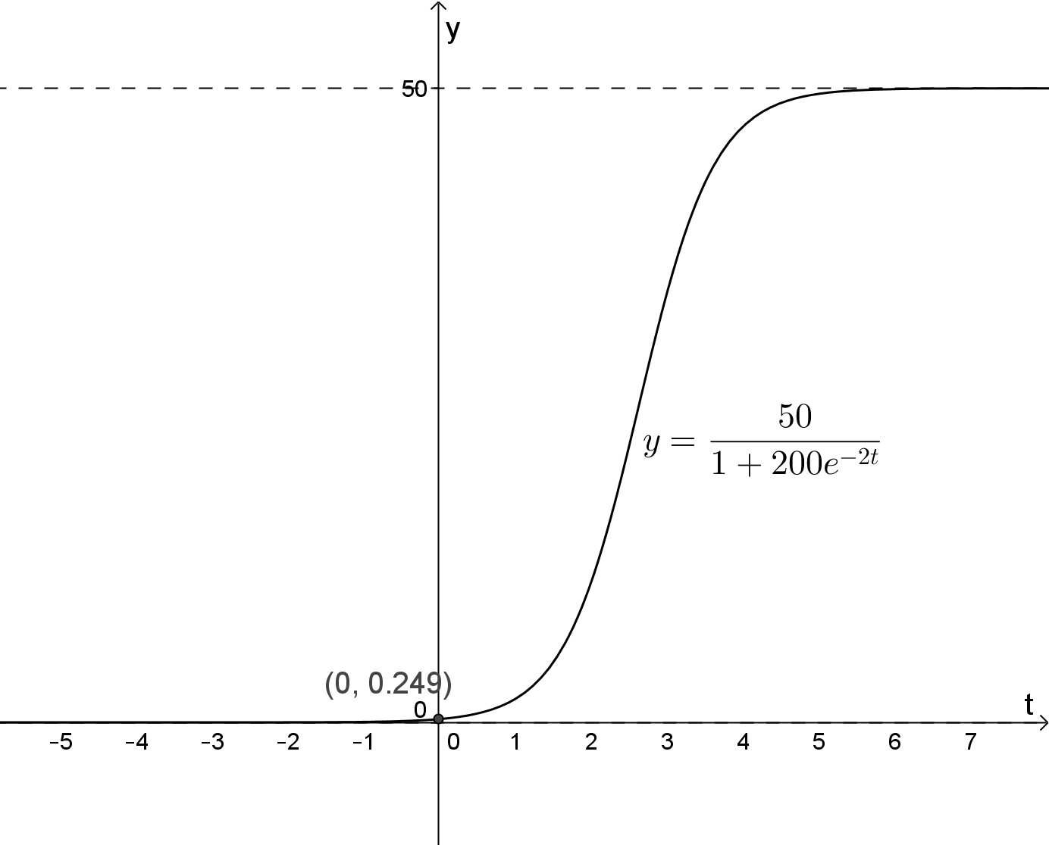
Mathematical behaviours | Marks
- Correct shape  - Shows asymptotes and vertical intercept | 1  1

Question 1 (b)(i)
Solution
Mathematical behaviours | Marks
- Correctly identifies the horizontal asymptote  - Correctly identifies the horizontal asymptote | 1  1

Question 1 (b)(ii)
Solution
Mathematical behaviours | Marks
- Correct vertical intercept | 1

Question 1 (b)(iii)
Solution
Mathematical behaviours | Marks
- Correct domain | 1

Question 1 (b)(iv)
Solution
Mathematical behaviours | Marks
- Correct range | 1

Question 2(a)
Solution
The predicted population in 2000 is approximately 100.7 million and in 2050 it is approximately 438.7 million.
Mathematical behaviours | Marks
- Uses exponential form to determine population  - Determines  - Solves for  - Predicts population in 2000  - Predicts population in 2050 | 1  1  1  1  1

Question 2(b)
Solution
Mathematical behaviours | Marks
- Rewrites fraction | 1
Question 2(c)
Solution
The predicted population in 2050 is approximately 144.7 million.
Mathematical behaviours | Marks
- Solves for  - Solves for  - Predicts population for 2015 | 1  1  1

Question 2(d)
Solution
The carrying capacity for this country is approximately 189.4 million.
Mathematical behaviours | Marks
- Correct carrying capacity | 1

Question 3(a)
Solution
The predicted population on 1 January 2017 is approximately 3080 perch.
Mathematical behaviours | Marks
- Recognises  - Determines  - Determines  - Predicts population | 1  1  1  1

Question 3(b)
Solution
The population is expected to be 3400 perch in July 2019.
Mathematical behaviours | Marks
- Substitutes  - Solves for  - Determines correct month and year | 1  1  1

Question 4(a)
Solution
Mathematical behaviours | Marks
- Chooses quotient rule  - Simplifies  - Substitutes for in  - Concludes that | 1  1  1  1

Question 4(b)
Solution
Mathematical behaviours | Marks
- Correct denominators  - Determines  - Determines  - Correctly writes fraction as sum of two fractions | 1  1  1  1

Question 4(c)
Solution
Mathematical behaviours | Marks
- Separates variables  - Uses partial fractions  - Correct antiderivatives  - Uses relationship between  - Rearranges to obtain as a function of | 1  1  1  1  1

TASK 15: INVESTIGATIVE QUESTIONS

Unit 4

Topic 4.2: Rates of change and differential equations

Course-related information

The concepts and skills included in this investigation relate to the following dot points within the WA Mathematics Specialist syllabus.

4.2.1 use implicit differentiation to determine the gradient of curves whose equations are given in implicit form
4.2.2 examine related rates as instances of the chain rule:
4.2.3 apply the incremental formula to differential equations
4.2.7 consider and solve problems involving motion in a straight line with both constant and non-constant acceleration, including simple harmonic motion and the use of expressions, for acceleration.

Background information

Each of the questions provided are stand-alone and may be incorporated into different tasks. It is not intended that they form part of the same task.

Task conditions

These questions are independent of each other and are written so that they may be incorporated into a test or examination. Students access to a CAS calculator is assumed. The time required to complete each question is left to the discretion of the teacher but the intention is that each question may be completed within 15 minutes.
Investigative questions for Topic 4.2

Question 1 (12 marks)

Given , the notation represents the partial derivative of with respect to and represents the partial derivative of with respect to .

To determine , the function is differentiated with respect to when is held constant.
To determine , the function is differentiated with respect to when is held constant.

For example,

(a) Determine for . (4)

(b) Given , determine
(i) (1)

(ii) (1)

(iii) (1)

(c) Compare in (b) and in (a). What do you notice? (1)
(d) Hence, use partial derivatives to determine for
Do not simplify. (4)

Question 2 (13 marks)

(a) The graph of is shown below.

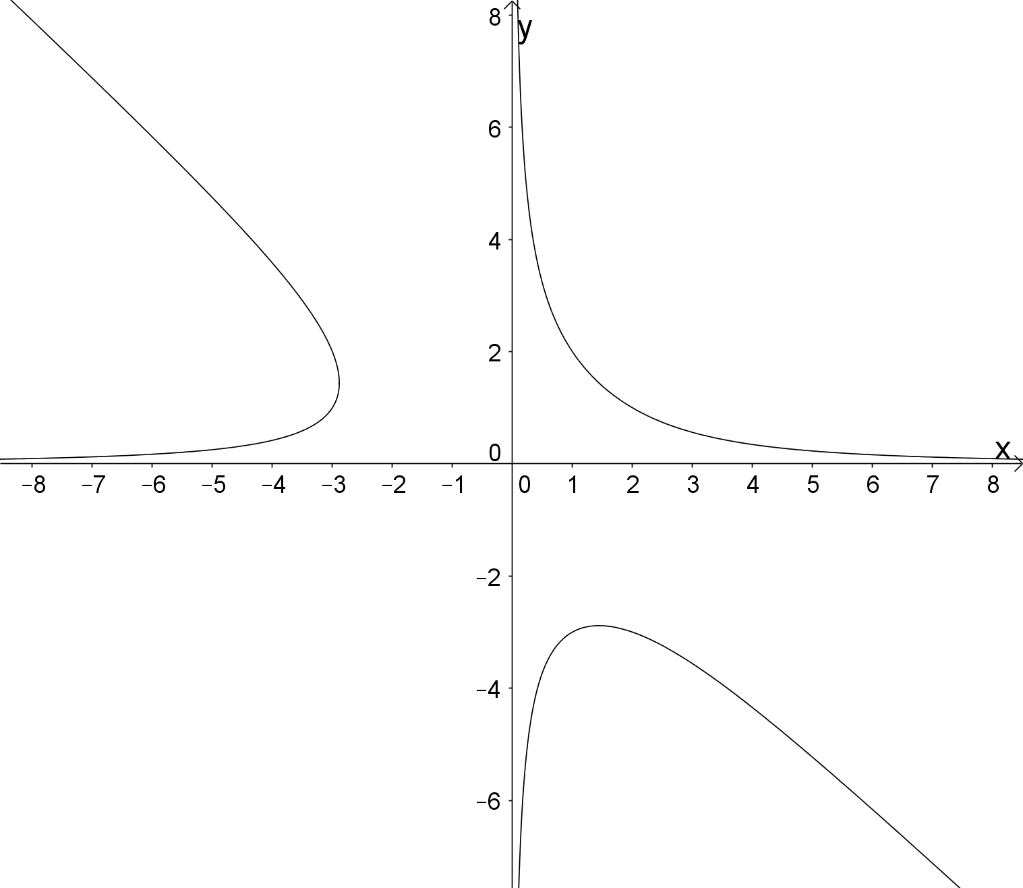

Determine the point of intersection of the lines tangential to this curve at .
(6)

(b) Given , where is a differentiable function,determine:

(i) whether is increasing or decreasing at , (4)

(ii) an approximation for . (3)

Question 3 (12 marks)

The graph below shows the velocity, , of a particle moving along the for . The graph consists of two line segments and a semi-circle.

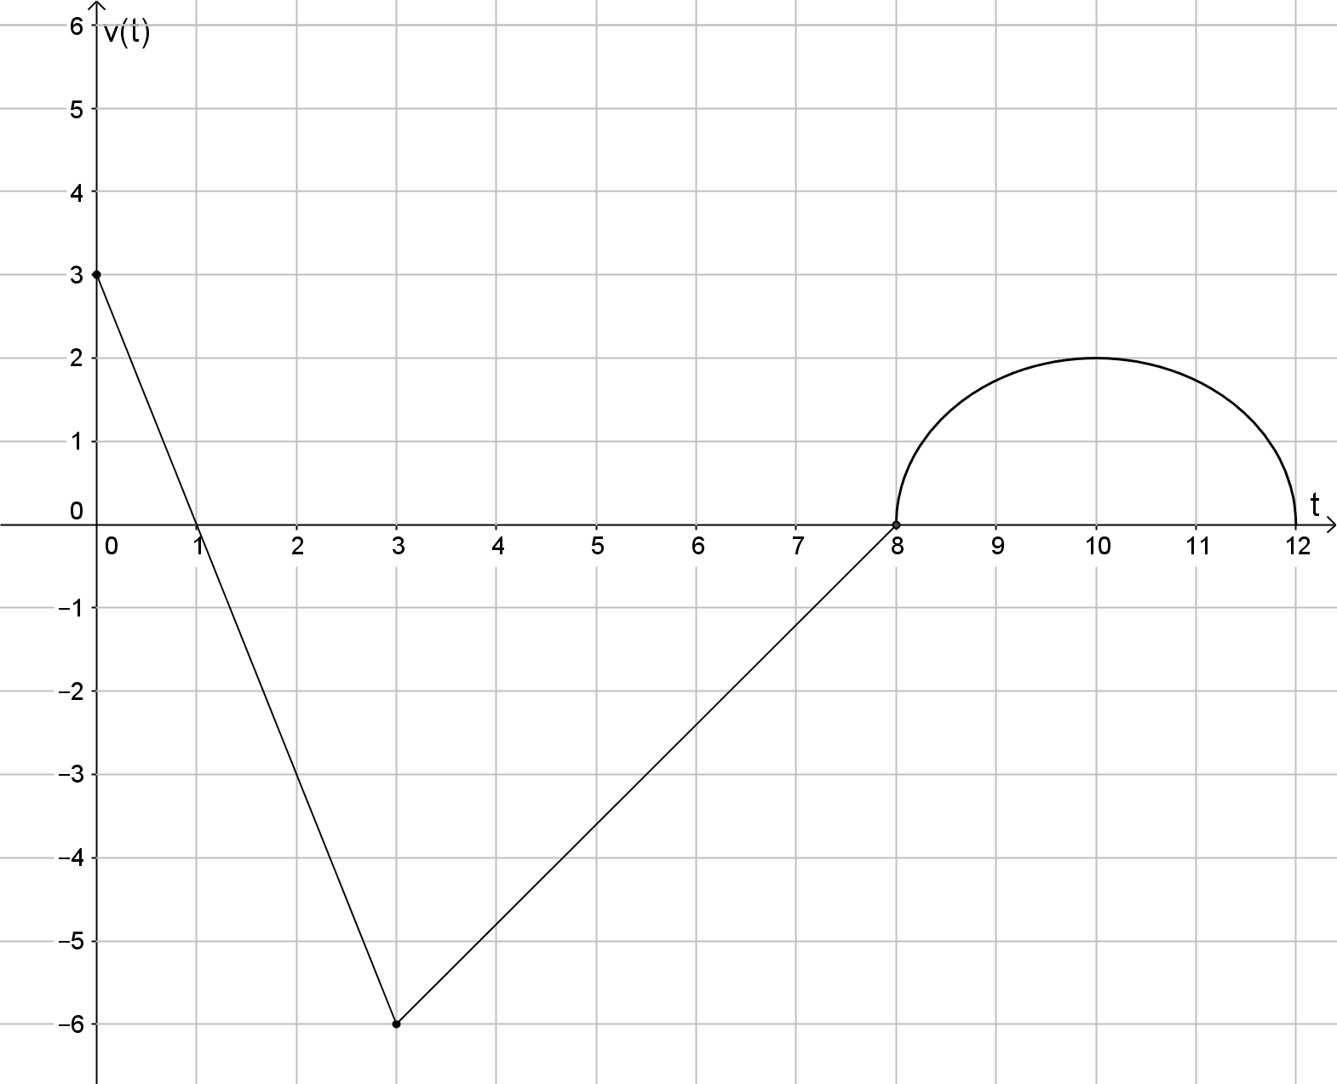

(a) At what time is the speed of the particle the greatest? (1)

(b) At which of the times, is the acceleration of the particle the greatest? Justify your answer. (2)

(c) Over what time intervals is the particle moving to the right? Justify your answer.
(2)

(d) Over what time intervals is the speed of the particle increasing? Justify your answer. (2)

(e) Determine the total distance travelled by the particle over the time interval (2)

(f) At , is the particle to the left or to the right of its starting point? Justify your answer. (3)

Investigative questions for Topic 4.2
Solutions and marking key

Question 1(a)
Solution
Mathematical behaviours | Marks
- Uses implicit differentiation  - Differentiates left side of equation correctly  - Differentiates right side of equation correctly  - Determines | 1  1  1  1

Question 1(b)(i)
Solution
Mathematical behaviours | Marks
- Determines correct partial derivative with respect to | 1

Question 1(b)(ii)
Solution
Mathematical behaviours | Marks
- Determines correct partial derivative with respect to | 1

Question 1(b)(iii)
Solution
Mathematical behaviours | Marks
- Determines | 1

Question 1(c)
Solution
Mathematical behaviours | Marks
- Correct conclusion | 1

Question 1(d)
Solution
Mathematical behaviours | Marks
- Rearranges equation  - Determines  - Determines  - Uses | 1  1  1  1

Question 2(a)
Solution
Mathematical behaviours | Marks
- Uses implicit differentiation  - Determines  - Substitutes and solves resulting equation for  - Determines equation of tangent at  - Determines equation of tangent at  - Determines coordinates of point of intersection of tangents | 1  1  1  1  1  1

Question 2(b)(i)
Solution
Mathematical behaviours | Marks
- Applies the chain rule  - Substitutes  - Calculates gradient at  - Correct conclusion | 1  1  1  1

Question 2(b)(ii)
Solution
Mathematical behaviours | Marks
- Chooses the incremental formula  - Uses  - Approximates | 1  1  1

Question 3(a)
Solution
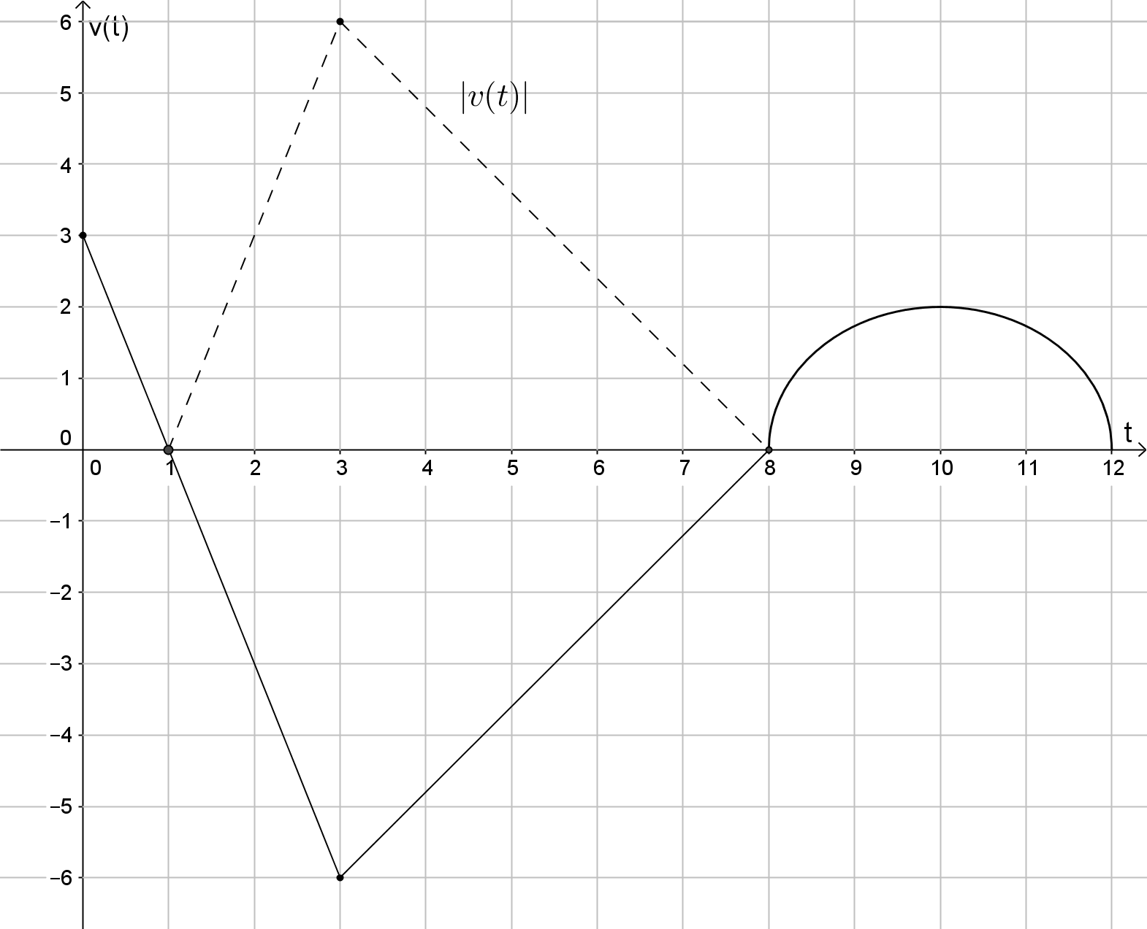
The speed of the particle is greatest at since that is when the magnitude of the velocity is greatest.
Mathematical behaviours | Marks
- Correct time | 1

Question 3(b)
Solution
Hence, the acceleration of the particle is greatest at
Mathematical behaviours | Marks
- Correct time  - Justifies answer | 1  1

Question 3(c)
Solution
Particle is moving to the right when .
Time intervals:
Mathematical behaviours | Marks
- Correct time intervals  - Justifies answer | 1  1

Question 3(d)
Solution
Speed of the particle is increasing when is increasing.
Time intervals:
Mathematical behaviours | Marks
- Correct time intervals  - Justifies answer | 1  1

Question 3(e)
Solution
Mathematical behaviours | Marks
- Recognises distance travelled is the sum of the areas of regions  - Correct distance | 1  1

Question 3(f)
Solution
Mathematical behaviours | Marks
- Calculates distance travelled to the right  - Calculates distance travelled to the left  - Correct conclusion | 1  1  1

